What will we be learning?  Unit 3 – Sports organisation and development | Why this? Why now?  This unit is externally assessed in January of Year 13 so studying this unit in the Autumn term prepares you for this examination. | Key Words:  Organisations  National governing bodies  Sports development  Participation  Performance  Sports development continuum  Target groups  Benchmarks  Quality schemes  Initiatives
What will we learn?
- LO1 – Understand how sport in the UK is organised
- LO2 – Understand sport development
- LO3 – Understand how the impact of sports development can be measured
- LO4 – Understand sports development in practice
What opportunities are there for wider study?
Careers/degree courses
- Sports science
- Physiotherapy
- PE teacher

Further reading:
UK Sport | UK Sport
National governing bodies | Sport England
Campaigns and our work | Sport England
How will I be assessed?
- End of unit tests
- Mock exam
CAM TECH – SPORT
UNIT 3

LO1 – UNDERSTAND HOW SPORT IN THE UK IS ORGANISED  - Roles and responsibilities:  - Government organisations  - National governing bodies  - Sport England  - UK Sport  - National Disability Sports Organisations  - National Lottery  - Sport & Recreation Alliance  - Active Partnerships  - Local councils  - International organisations which impact UK sport | 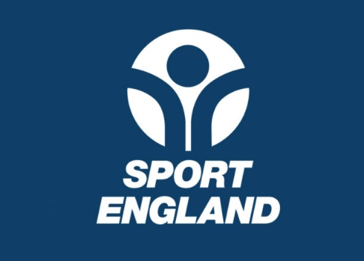
LO2 – UNDERSTAND SPORTS DEVELOPMENT  - What sports development is  - Purpose of sports development  - Sport development continuum levels  - Target groups | 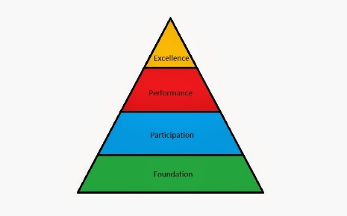
LO3 – UNDERSTAND HOW THE IMPACT OF SPORTS DEVELOPMENT CAN BE MEASURED  - Possible measures  - Methods of measuring performance and participation  - Purpose of measurement | 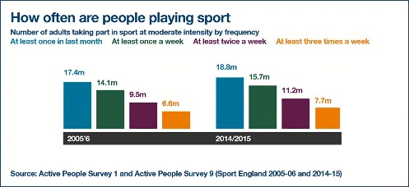
LO4 – UNDERSTAND SPORTS DEVELOPMENT IN PRACTICE
- Methods of delivering sports development
- Characteristics if sports development initiatives and events
- Advantages and disadvantages of sports development initiatives and events
- Benefits of sports development

